

Consultancy Report

ON

Preliminary Design of UNC Charlotte MARVEL Campus-Design plan for the modernization of Advanced Research On Vehicle Electrification And Locomotives in Gastonia, North Carolina

Consultancy No. Group 3-03

November 20th - 2024

Sri Vishnu Consultancy Group 3

INDEX

SL | Contents | Page
 | Preface | 3
 | Synopsis | 4
1. | Introduction | 4
2. | Reference | 5
3. | SWOT Analysis | 6
4. | Recommendations | 10
5. | Summary | 11

PREFACE

This report is prepared on the basis of report submission & detailed discussion with the UNC Charlotte Design Team # 3 with Team CEO Noah Kent, Charlotte, NC, USA. Views expressed are subject to modification from time to time in the light of future developments on the subject and as such, do not represent the views of Sri Vishnu Engineering College for Women, Bhimavaram, Andhra Pradesh, India.

This report is the property of the SVECW and is meant essentially for officials use. It may not be loaned, reproduced in part or in full or quoted as an authority without the permission of Director General, RDSO.

(Noah Kent)
CEO/ Team Leader

(Pilli Anusha)

Communication Officer/Liaison to US Team

SYNOPSIS

This consultancy report, prepared by the Sri Vishnu Consultancy Group, presents that the preliminary design for the UNC Charlotte MARVEL Campus in Gastonia, North Carolina.

The report covers foundational aspects such as soil analysis, material testing, and the design is the recommendations. Key findings include detailed test results for embankment and sub-soil conditions, addressing parameters like moisture content, density, and shear strength. Analysis of the existing situation, including strengths, weaknesses, opportunities, and threats.
The SWOT analysis highlights the project's strengths and challenges, leading to strategic recommendations aimed at optimizing campus development. The report's insights are tailored to guide efficient and sustainable implementation.

- Analysis of the existing situation, including strengths, weaknesses, opportunities, and threats.

- Includes SWOT analysis and strategic suggestions.

- Aims to guide efficient and sustainable campus development.

Project Purpose: A brief description of the objectives or goals of the consulting project.

Key Findings: The most significant insights or observations derived from the analysis.

Recommendations: A high-level overview of the proposed solutions or actions.

Introduction

The three conceptual designs for the MARVEL Campus presented in the report aim to establish a cutting-edge satellite campus for UNC Charlotte, emphasizing sustainable transportation research. Each design features three primary research and academic buildings—the Engineering Education Building, Flexible Research Laboratory, and RailSparc—with unique layouts to accommodate specific project needs.

Design #1: Preserve existing structures, add RailSparc hub, playground, and communal spaces.
The layout preserves the majority of the pre-existing buildings along the property’s border and focuses on re-purposing the central industrial facilities. This design incorporates a dynamic mix of functional and recreational areas, such as the RailSparc building with three attached train depots, a drone playground, and a water research pond

Design #2: Minimize rail infrastructure, centralize water pond and parking, prioritize efficiency.
This design reduces the need for additional rail tracks while re-purposing one restaurant into a parking lot for improved accessibility. Key features include the Flexible Research Laboratory and the Engineering Education Building.

Design #3: Reconfigure campus, remove select buildings, improve functionality and aesthetics.
This design prioritizes a centralized layout with the Engineering Education Building, Flexible Research Laboratory, and RailSparc building positioned for maximum collaboration. The water pond and drone playground are placed on the western side, creating dedicated research zones.

All designs feature innovative additions, including:

- Drone testing areas
- Water research pond
- "Sustainable Trees of Life" for energy

2.0 Reference

Primary Reference

Ancient Grains Engineering. (2024). Preliminary Desigsn Report for the MARVEL Campus. UNC Charlotte Sophomore Design Laboratory.

Additional References

1. Consultant Report Structure:
- Executive Summary
- Objective and Scope
- Methodology
- SWOT Analysis
- Findings and Recommendations
- Implementation Plan
- Appendices

1. SWOT Analysis Components:
- Strengths
- Weaknesses
- Opportunities
- Threats

2. Zoom Meeting Best Practices:
- Pre-meeting preparation
- Visual presentation of SWOT analysis
- Encourage participant engagement
- Post-meeting follow-up

3. Reference Sources:
- Books (e.g., "The McKinsey Way")
- Articles (e.g., Harvard Business Review)
- Online guides and tamplates

- SWOT Analysis

- Strengths:Internal factors that give a competitive advantage.
- Weeknesses:Internal factors hindering progress.
- Opportunities:External factors that can be leaveraged.
- Threats:External factors posing risks.
STRENGTHS ANALYSIS
 |  | TRUE | TRUE | TRUE
No | Strengths Item
No | Strengths Item | Design 1 | Design 2 | Design 3
1 | Community Support (Do you think community will like this design) | 3 | 4 | 3
2 | Infrastructure Availability (layout) | 4 | 2 | 3
3 | Sustainable design | 4 | 5 | 3
4 | Design efficieny (Site Use) | 3 | 4 | 2
5 | Design Readiness | 5 | 2 | 1
6 | Stormwater

Table 1 -Strength Analysis

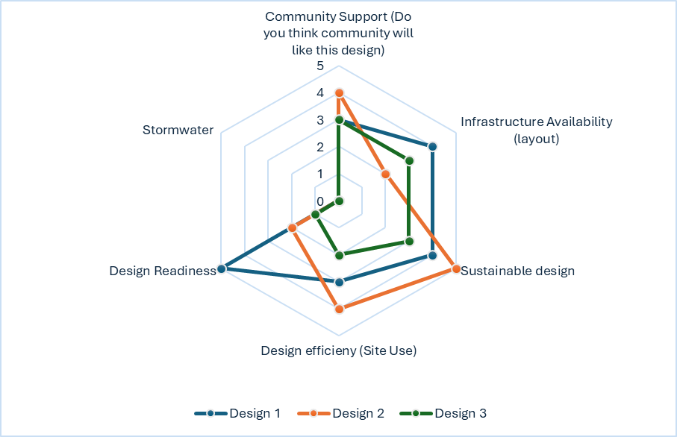
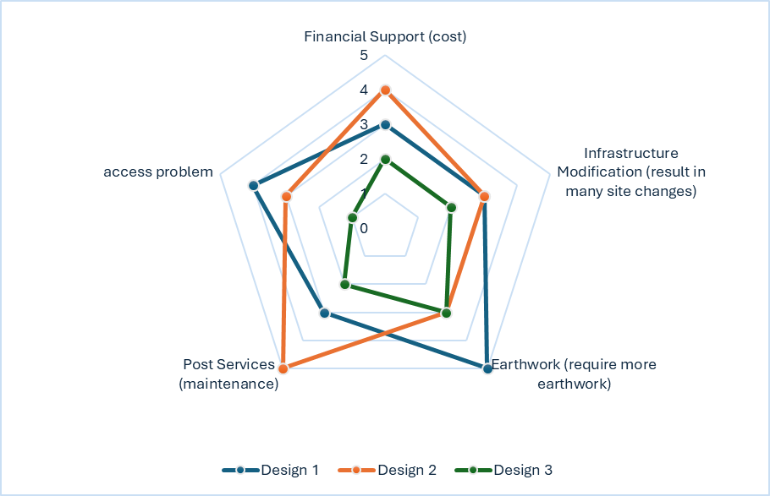
 | WEAKNESSES ANALYSIS
 |  |  |  | TRUE | TRUE | TRUE
 | No | Weaknesses Item
 | No | Weaknesses Item |  | Design 1 | Design 2 | Design 3
 | 1 | Financial Support (cost) |  | 3 | 4 | 2
 | 2 | Infrastructure Modification (result in many site changes) |  | 3 | 3 | 2
 | 3 | Earthwork (require more earthwork) |  | 5 | 3 | 3
 | 4 | Post Services (maintenance) |  | 3 | 5 | 2
 | 5 | access problem |  | 4 | 3 | 1

Table 3 – Opportunities Analysis
OPPORTUNITIES ANALYSIS
 |  | TRUE | TRUE | TRUE
No | Opportunities Item
No | Opportunities Item | Design 1 | Design 2 | Design 3
1 | Environmental Sustainability | 4 | 3 | 3
2 | Good Profit (help to local community) | 5 | 4 | 2
3 | Economic growth | 3 | 4 | 2
4 | Urban innovation | 2 | 3 | 5
5 | Exclusive contracts | 2 | 2 | 3

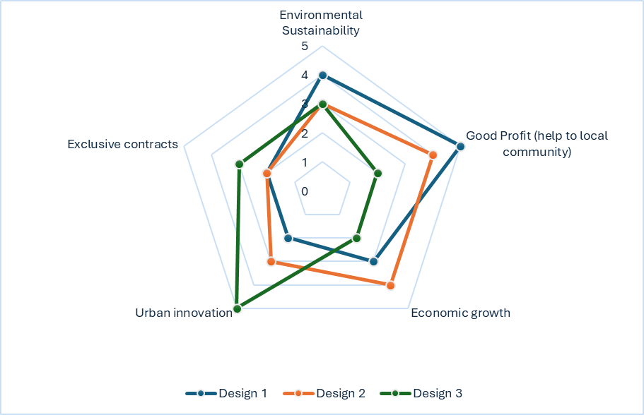

Table 4 – Threats Analysis
THREATS ANALYSIS
 |  | TRUE | TRUE | TRUE
No | Threats Item
No | Threats Item | Design 1 | Design 2 | Design 3
1 | Political Effect (local community will not like the design) | 3 | 3 | 2
2 | Alternate Design (may face competition) | 4 | 3 | 2
3 | Market Demand | 4 | 4 | 1
4 | Economic Situation (too expensive to build) | 2 | 3 | 3
5 | local ecology | 5 | 4 | 2

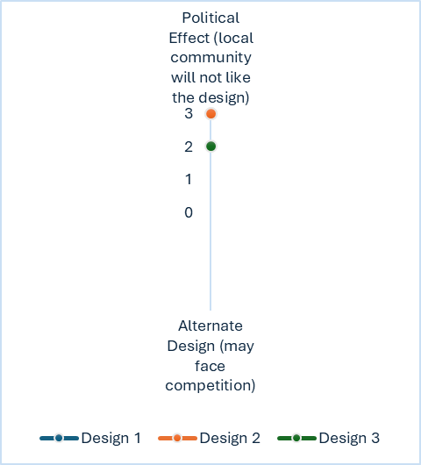

4.0 Recommendations

Strengths:
strengths are internal attributes or resources that provide an organization with a competitive edge. Points are assigned to strengths to prioritize their importance and impact. High points are given to strengths that are critical for success, unique in the market, or significantly contribute to achieving organizational goals—such as patented technology, exceptional brand reputation, or a highly skilled workforce. On the other hand, low points are assigned to strengths that are less impactful, underutilized, or common across the industry—like standard operational processes or basic resources that competitors also possess. Assigning these points helps organizations focus on maximizing high-priority strengths while addressing areas that need better utilization or enhancement.
Leverage Strengths: Maximize key strengths (e.g., technology, customer loyalty) and align them with opportunities to differentiate and grow.
Weaknesses:
weaknesses are internal factors that hinder an organization’s performance or place it at a disadvantage compared to competitors. Points are assigned to weaknesses to evaluate their severity and prioritize efforts to address them. High points are given to weaknesses that pose significant risks or challenges, such as financial instability, outdated technology, or poor management, as these issues can critically affect operations and growth. Conversely, low points are assigned to minor weaknesses or those with limited impact, like small inefficiencies or temporary skill gaps. This scoring helps organizations focus on resolving critical weaknesses first while monitoring less significant ones to prevent escalation.
Address Weaknesses: Improve internal inefficiencies, fill skill gaps through training, and create contingency plans for unresolved weaknesses.
Opportunities:
opportunities represent external factors or conditions that an organization can capitalize on to achieve its goals. When evaluating opportunities across multiple designs (e.g., Design 1, Design 2, Design 3), points are assigned based on the relevance, feasibility, and potential impact of each opportunity. High points are given to opportunities that strongly align with the design's objectives, are easily actionable, and have significant benefits—such as entering a growing market, leveraging new technology, or responding to environmental trends. On the other hand, low points are assigned to opportunities that are less relevant, harder to implement, or have limited potential benefits. This scoring helps prioritize which design best leverages the opportunities available, ensuring resources and efforts are directed toward the most promising option.
Capitalize on Opportunities: Pursue new markets, form strategic partnerships, and innovate to stay ahead of trends.
Threats:
Threats are external factors that could negatively impact an organization or project. When evaluating threats across different designs (e.g., Design 1, Design 2, Design 3), points are assigned to assess the potential severity and likelihood of each threat. High points are given to threats that pose significant risks, such as regulatory changes, intense competition, or shifts in market demand, which could severely affect the success of a particular design. These threats are urgent and require proactive measures to mitigate. Low points are assigned to threats that are less immediate or impactful, such as minor competitor actions or temporary market fluctuations. By assigning points, organizations can identify which design is most vulnerable to external risks and make informed decisions on how to address or avoid those threats.
Mitigate Threats: Monitor external risks, diversify offerings to reduce dependence, and implement proactive risk management strategies.

5.0 Summary

1. Design #1:

Preserves most pre-existing buildings and integrates the existing railway.

Focuses on connectivity with external businesses and features a central RailSparc building with train depots and a turntable.

Includes a drone playground, water research pond, and "Trees of Life" as sustainability symbols.

Prioritizes communal spaces for study and recreation.

2. Design #2:

Introduces a more compact layout, with fewer additional rail tracks.

Locates the Flexible Research Laboratory and drone testing area in the west, ensuring designated parking for these activities.

Positions the Engineering Education Building and water pond centrally, optimizing access and equipment storage.

RailSparc connects more directly to the pre-existing railway for efficiency.

3. Design #3:

Requires significant removal of existing structures to create space for the campus.

Relocates the water pond and drone testing to the west and focuses collaborative research areas in the central and northern sections.

Features a parking deck for students, though the layout may inconvenience access to western facilities.

Maximizes land use with aesthetic placements and optimal accessibility for the RailSparc and Trees of Life.

Additional Elements:

Drone Playground: Testing space for aerial drones and recreational use.

Water Pond: For underwater research and testing of aquatic drone technologies.

Trees of Life: Vertical wind turbines with solar panels serving as sustainable energy sources.

Design Overview:

Three designs are proposed, each with different approaches to layout, preservation of existing structures, and sustainability integration.

The designs are evaluated based on strengths, weaknesses, opportunities, and risks, allowing for a data-driven selection process.

Officers And Staff Associated with Preparation Of report

The report has been prepared by Pilli Anusha, CEO/Team Leader under guidance of Dr. Pala Gireesh Kumar, Professor and Head, Department of Civil Engineering, Shri Vishnu Engineering College for Women (A).

This report has been prepared on the basis of the report provided by the US Team & detailed discussion with the UNC Charlotte Design Team # 3 with Team CEO Noah kent, Charlotte, NC, USA.

The following officer and staff that were associated with the preparation of report.

Team CEO NOAH KENT,Charlotte,NC,USA.
CEO/Team Leader PILLI ANUSHA Regd No-23B01A0138

Team members with their Register Numbers
1.PENTAKOTI JHANSI LAKSHMI PRASANNA DURGA-23B01A0134
2.PENUMALA PRINSI-23B01A0135
3.PENUMALA VIJAYA KUMARI-23B01A0136
4.PERAPU VEERA LAHARI KEERTHI BHAVYA-23B01A0137
5.PISINI ANUSHA-23B01A0139
6.PODALA PHANISRI-23B01A0140
7.POKALA JAYA SRI-23B01A0141
8.RAYUDU PREMAKUMARI-23B01A0142
9.SANKURATRI SAI SARANYA-23B01A0143
10.SARIKI ADI LAKSHMI-23B01A0144
11.SIGA NAVYA SRIDEVI-23B01A0145
12.SODE SHIRISHA-23B01A0146
13.TAKASI KAVYA SRI-23B01A0147

